***Visit a Classroom* Program Manual**

“*Visit a Classroom*” program is originated by Anne Wessely, St. Louis Community College as “Teaching Squares”, or “Teaching Triangles” an abridged version. This guideline is adapted from several workbooks, including:

* Teaching Squares, University of Hawai‘i Leeward Community College <http://www.leeward.hawaii.edu/teachingsquares>
* Participant Handbook, Center for Teaching and Learning, Stonehill College Easton, MA <https://stonehill-website.s3.amazonaws.com/files/resources/participant-handbook-08-09.pdf>
* Teaching Triangles, Bowdoin College <https://www.bowdoin.edu/baldwin-center/pdf/teaching-triangles-overview.pdf>

**What is the purpose?**

Visiting a classroom allows you to observe, analyze, and celebrate good teaching; to reconnect with the student perspective; and to formulate plans for enhancing your own teaching based on your observations and reflections and the shared reflections of your faculty participant partners.

**What are the guidelines?**

***Reciprocity and Shared Responsibility*:** Through the mutual exchange of visits, participants are both observer and observed, student and teacher. Visit a classroom participants are responsible for arranging classroom visits and exchanging pertinent course information.

***Self-Referential Reflection*:** The final meeting is an opportunity to report what we have learned from the observing the class. It is **NOT** an opportunity to improve another participant’s teaching. There will be **no evaluation or judgment**.

***Appreciation*:** The final session is an opportunity to identify and celebrate the behaviors and practices that create a productive environment for learning that you observed.

***Mutual Respect*:** Participants enter one another’s classrooms with an attitude of empathy and respect, recognizing that different methods and techniques are required in different disciplines and classroom situations.

**How can I participate to visit a class?**

To sign up the “*Visit a Class*” program, please fill out the request form by sharing your teaching schedule (Session 1 or Session 2), course information (including class size, type of course, major classroom activities and etc.), topics or questions about teaching that you are interested in discussing with other faculty.

After submitting an application, you will be contacted when we match you with two other faculty with complimentary schedules and interests.

**How does *Visit a Classroom* work?**

Each member of a group of 3 faculty participants:

1. Meets with two other faculty participants and a Duke Kunshan Center for Teaching and Learning (CTL) staff to discuss their teaching and plan classroom visits.
2. Observes at least one class taught by each faculty partner (a total of 2 to 3 observations)
3. Reflects on the class observation experience *in writing,* specifically on what you would change in your own teaching as a result of observing the other classes. All reflections should be positive and refer to yourself.
4. Gathers over lunch (provided by CTL) to share observations with the other two faculty participants.

**How should I prepare to be visited?**

* Determine the dates you would be willing to have a visitor.
* Share your syllabus, goals for the session and any background material that will help a visitor comprehend what the students are doing during class.
* Explain to your students that the course will be visited, and why. Students are generally impressed that their professor is participating in a project to improve teaching.
* Introduce your faculty visitor to the class.

**How should I prepare to visit?**

* Confirm the date, time, and room about 24 hours before the intended visit.
* Read the materials provided by the instructor, and be clear on what the goals are of the session.
* Arrive early and ask where you can sit. Prepare to be in the class for the duration of the class session.
* Take notes on your observations during the class. Check with the instructor if you intend to take notes on a computer.

**What should I take notes on?**

Do whatever will work for you, but don’t get so caught up in being a student that you do not observe the instructor! Here are three suggestions for how to approach the class visit.

**1. “Chose a Lens” to focus your observations**

One approach that works for some people is to choose a particular “lens” through which to focus their observations. Going in with some specific questions in mind can help you focus your attention and lead to a more meaningful observation. Here are some possible lenses:

Example from: Center for Teaching and Learning, Stonehill College Easton, MA

<https://stonehill-website.s3.amazonaws.com/files/resources/participant-handbook-08-09.pdf>

**Motivation**

* How do I arouse curiosity in my students?
* How do I keep my students engaged in the material?
* When my class ends, do students leave wanting to know more?
* How do I show my learners I am interested in them?

**Content**

* Do I survey my learners to assess what they already know?
* Do I summarize my central points clearly?
* Do I give some space to my students to set the agenda?
* Are my examples relevant and current?

**Diversity**

* Am I knowledgeable of my classroom demographics?
* How do I accommodate differences in my learners?
* How do I ensure my curriculum addresses diversity?
* How inclusive am I in my teaching practice?

**Instructional Strategies**

* Is there variety in the way I deliver material?
* How can I encourage self-reflection and critical thinking?
* How effectively do I handle small group work?
* How do I handle unexpected moments in the classroom?
* Do I model different learning processes?
* Do my questions generate meaningful discussion?

**Classroom climate**

* Do my students feel respected?
* Do my students feel comfortable asking and answering questions?
* Do I set clear parameters for participation?
* Can my students challenge my position on an issue?

**2. “Double Entry” observation notes**

Some people find it helpful to organize their observation notes by dividing them into *descriptions* and *reflections*. The description can reflect the instructor’s actions, students’ reactions, and the content being conveyed, while your reflections can track your own reactions to what’s happening in class. Reflections can be recorded both during class and afterwards. Tracking the time can be helpful.

Example from: Center for Teaching and Learning, Stonehill College Easton, MA

<https://stonehill-website.s3.amazonaws.com/files/resources/participant-handbook-08-09.pdf>

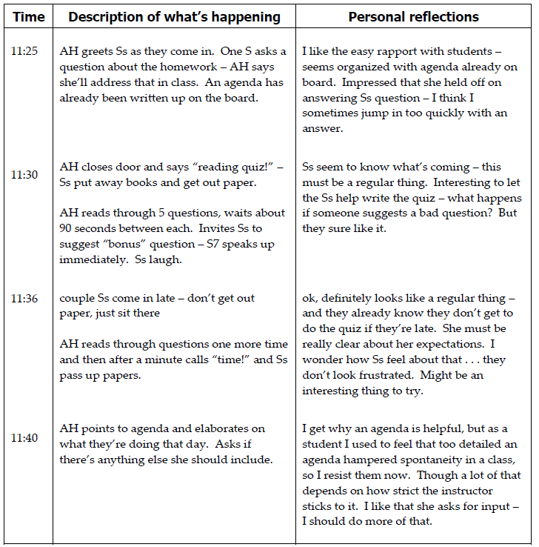

**3. Map a class discussion**

Notes such as these can be usefully paired with one of the discussion “maps”. Here’s an example:

Example from: Center for Teaching and Learning, Stonehill College Easton, MA

<https://stonehill-website.s3.amazonaws.com/files/resources/participant-handbook-08-09.pdf>

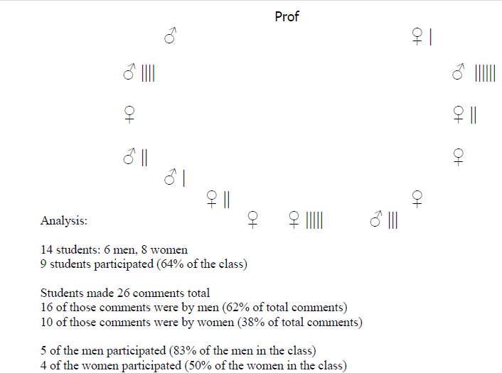

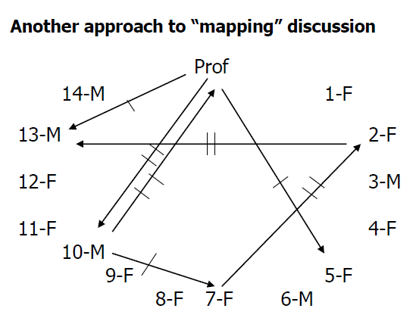

**How to prepare and share my reflection?**

Within one week of your observations, write your reflections and a plan for how your observations will impact your teaching. See the reflection questions listed below to prepare what you will share with the group. Share only those comments that are positive and supportive of your peers, and your ideas for modifying your own teaching.

Example from: Teaching Squares: Observe and reflect on teaching and learning

<http://connections.ucalgaryblogs.ca/2017/10/05/teaching-squares-observe-and-reflect-on-teaching-and-learning/>

* What have you learned about your teaching philosophy from your classroom observations (something new or something that has been affirmed)?
* What personal values do you bring to your teaching?
* How has the experience of again being in the “learner” role impacted your teaching?
* What have you learned is one of your teaching strengths?
* What aspect of your teaching do you wish to rethink? How are you going to do this?
* What surprised you during this experience? What assumptions about teaching were challenged by what you observed?
* What is one thing you learned that will make your teaching more effective?
* What is one thing you learned that you are going to apply next semester in your classroom?

When you have visited each classroom and been visited in turn, arrange to meet with your partners and your CTL staff over lunch (provided by CTL) to share positive reflections of your visit to each other’s’ classes.